Ex.no:6
Date:11/4/25
6. Write a Servlet to demonstrate session tracking using HTTP Session.
Implement a simple login system where the user's session is tracked.

Aim:
To Write a Servlet to demonstrate session tracking using HTTP Session.
Implement a simple login system where the user's session is tracked.
Program:
SessionHandle.html
<!DOCTYPE html>
<html>
<head>
<meta charset="ISO-8859-1">
<title>Login</title>
</head>
<body>
<form action="HttpSessionHandle" method="POST" style="margin-left: 50px">
<p>
<label>Username: </label><input type="text" name="username"/><br><br>
</p>
<p>
<label>Password: </label><input type="password" name="password"/><br><br>
</p>
<p>
<input type="submit" value="Login" style="margin-left: 130px"/>
</p>
</form>
</body>
</html>

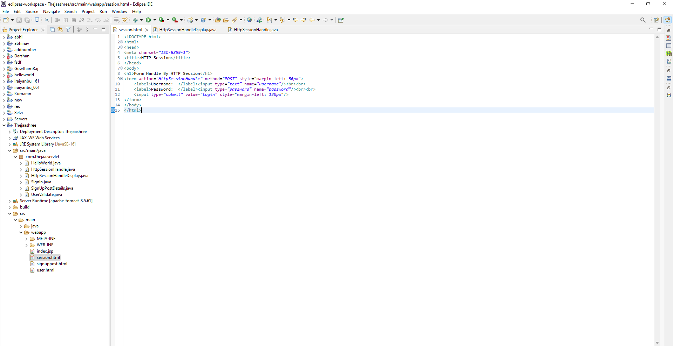

HttpSessionHandle.java
package com.thejaa.servlet;

import java.io.IOException;
import java.io.PrintWriter;
import javax.servlet.ServletException;
import javax.servlet.annotation.WebServlet;
import javax.servlet.http.*;

@WebServlet("/HttpSessionHandle")
public class HttpSessionHandle extends HttpServlet {
private static final long serialVersionUID = 1L;

public HttpSessionHandle() {
super();
}

protected void doGet(HttpServletRequest request, HttpServletResponse response) throws ServletException, IOException {
PrintWriter p = response.getWriter();
HttpSession session = request.getSession(false); // false = don't create if not exists

if (session != null && session.getAttribute("username") != null) {
String user_name = (String) session.getAttribute("username");
p.println("Username is " + user_name);
} else {
p.println("No active session. Please login.");
}
}

protected void doPost(HttpServletRequest request, HttpServletResponse response) throws ServletException, IOException {
doGet(request, response);
}
}
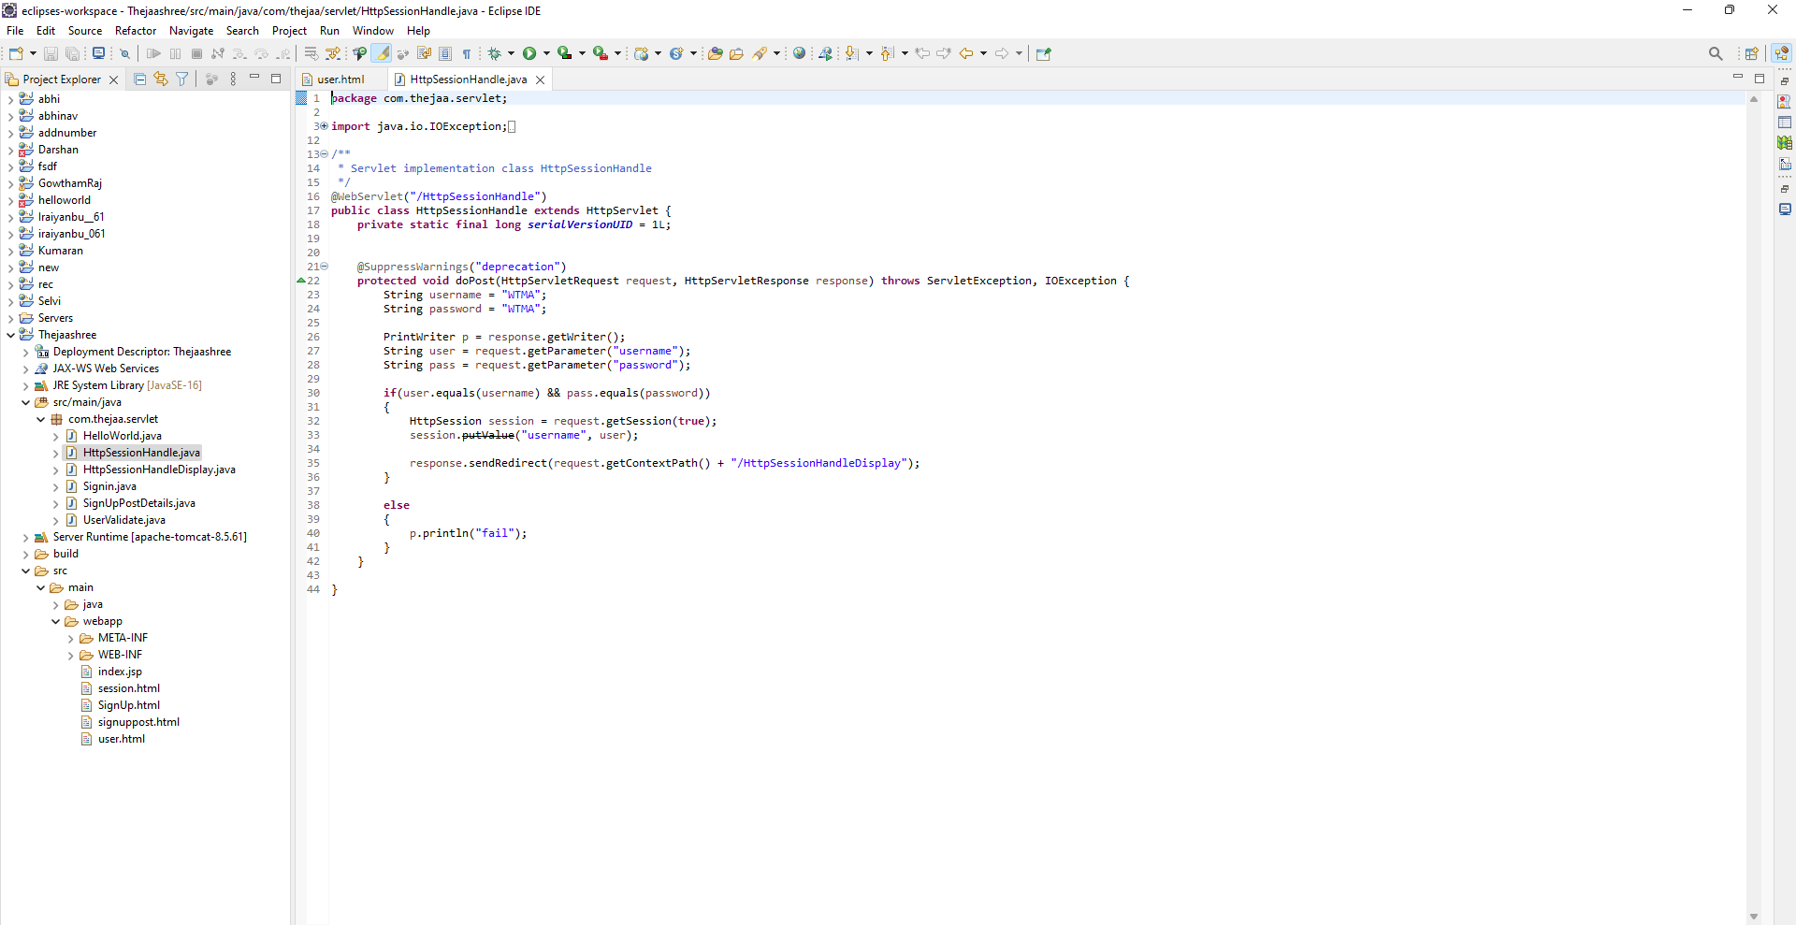

HttpSessionHandleDisplay.java
package com.thejaa.servlet;

import java.io.IOException;
import java.io.PrintWriter;
import javax.servlet.ServletException;
import javax.servlet.annotation.WebServlet;
import javax.servlet.http.*;

@WebServlet("/HttpSessionHandleDisplay")
public class HttpSessionHandleDisplay extends HttpServlet {
private static final long serialVersionUID = 1L;

public HttpSessionHandleDisplay() {
super();
}

protected void doGet(HttpServletRequest request, HttpServletResponse response) throws ServletException, IOException {
// You can handle GET if needed, or leave this empty
}

protected void doPost(HttpServletRequest request, HttpServletResponse response) throws ServletException, IOException {
String username = "sheeja";
String password = "sheeja05";

PrintWriter p = response.getWriter();
String user = request.getParameter("username");
String pass = request.getParameter("password");

if (user.equals(username) && pass.equals(password)) {
HttpSession s = request.getSession(true);
s.setAttribute("username", user);
// Correct path for redirect
response.sendRedirect("HttpSessionHandleDisplay");
} else {
p.println("Login Failed");
}
}
}
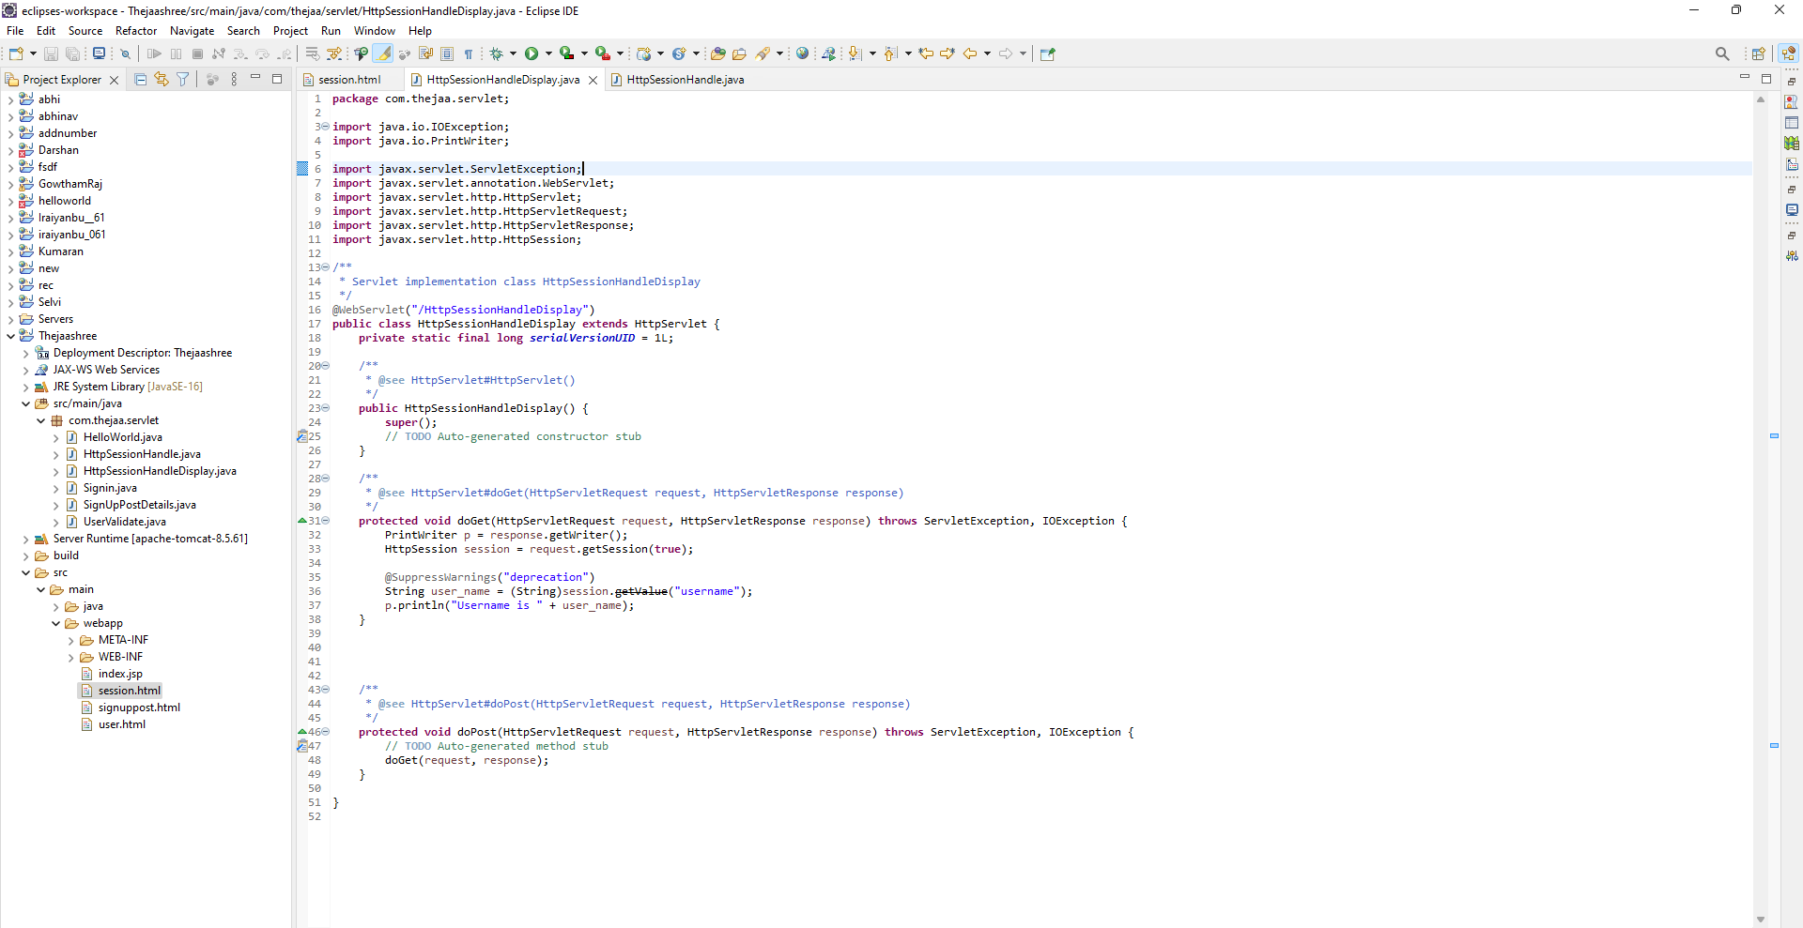

Output:

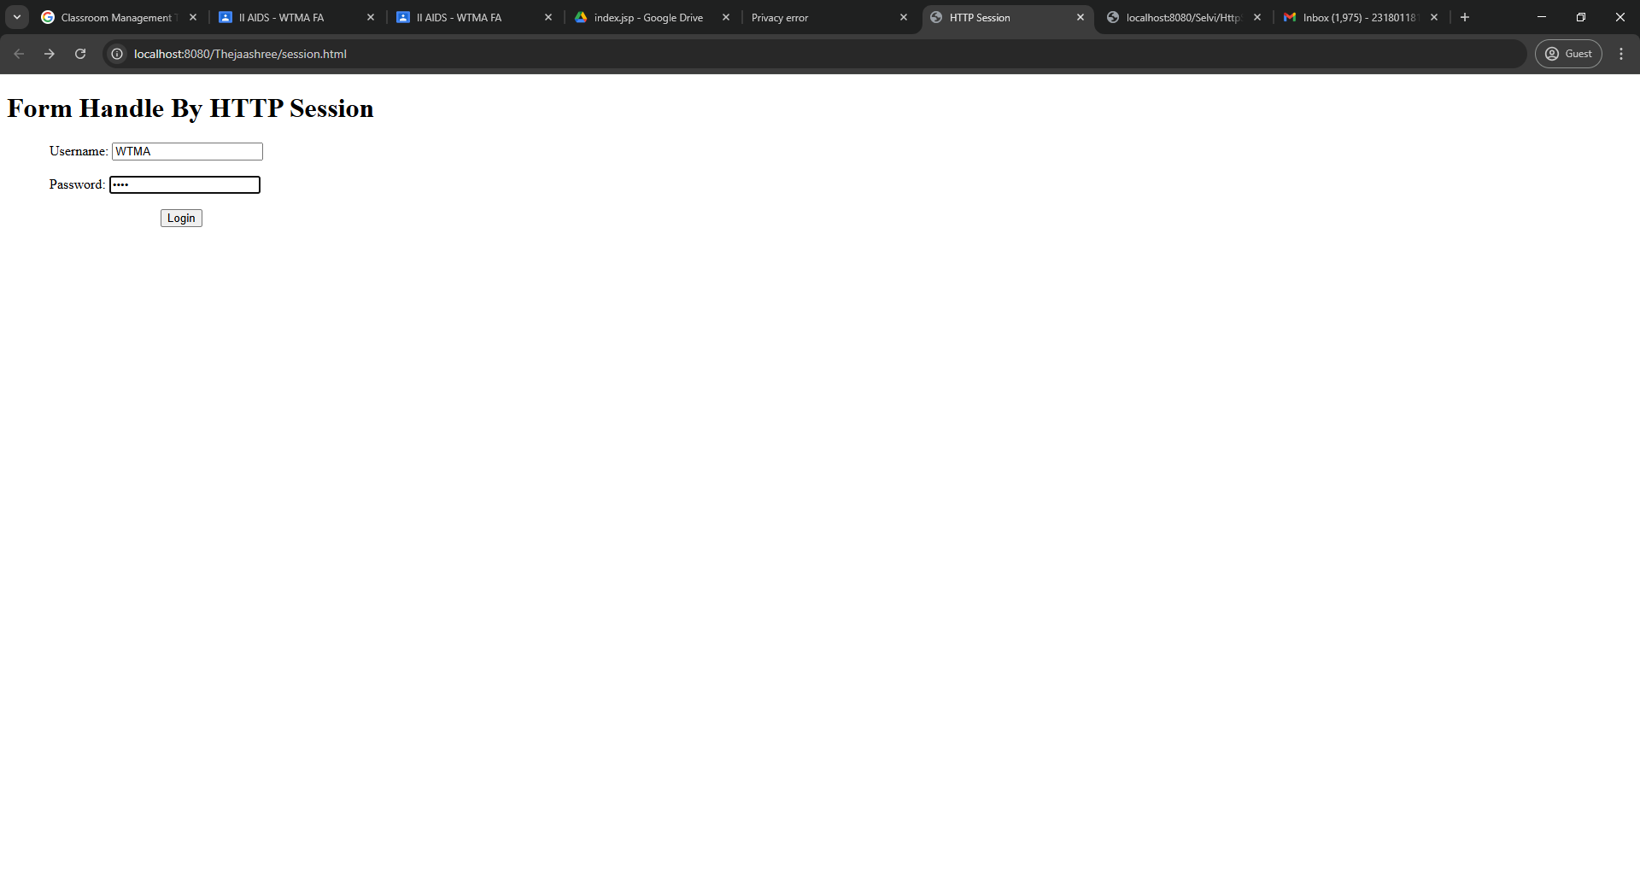
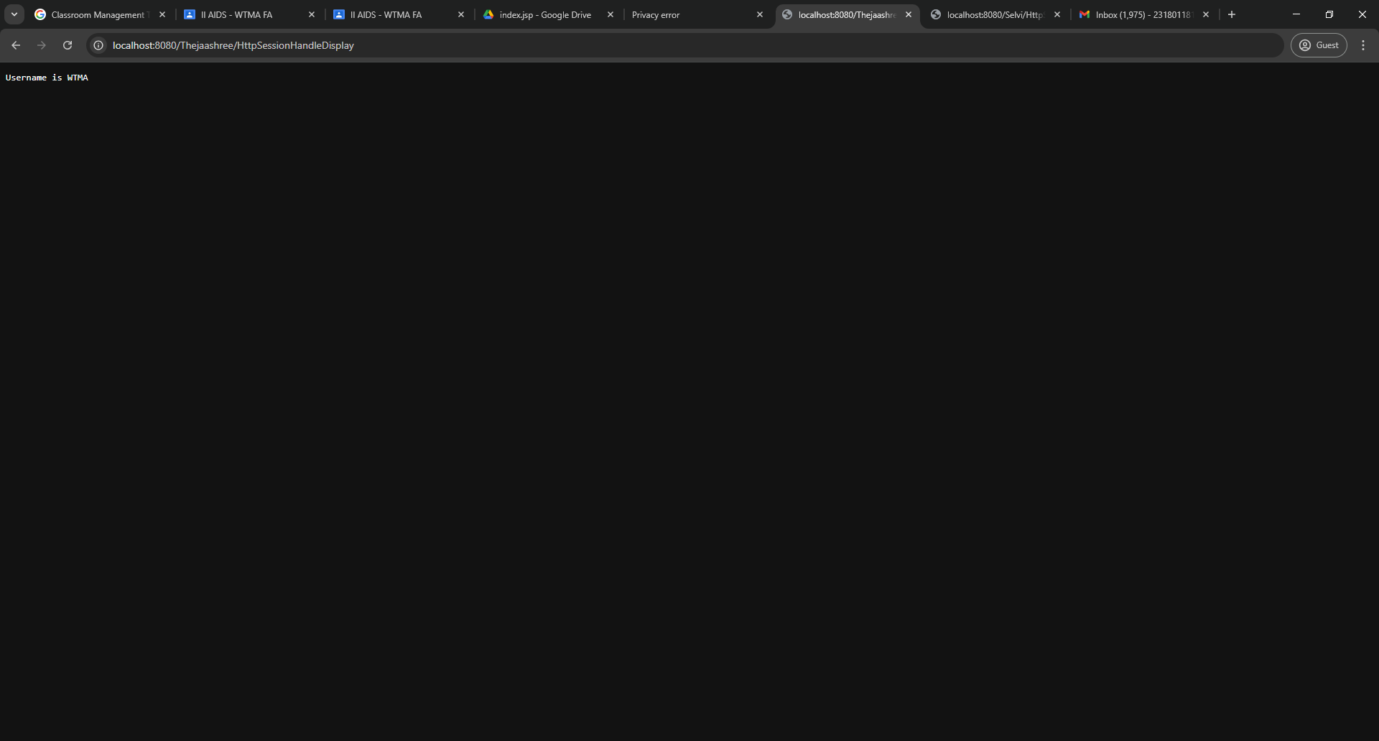

Result:
Thus the program was executed successfully on web browser and Implemented a simple login system where the user's session is tracked.

